# Requirements for Distributed Transaction Systems
Our online commercial world exists because various autonomous entities (users, institutions) can interact with each other in a series of distributed transactions. The most common of these transactions involve a user interacting with an “inventory manager” that manages anything from goods (an online retailer) through seats or accommodations (an airline or hotel) to entities with no physical existence (the money in a user’s bank account).

The simplest scenario for these transactions involves just two participants – in this document, a participant and a partner. That transaction is most useful thought of as two coordinated workflows (one for each participant and the partner process) tied together through messages sent between the participants: a conversation.
While the processing performed on the local data managed by the participant and the partner is, of course, necessary, the messages are the most important part of the process: without messages there is no transaction. Further, the messaging must support the workflows of the participants: A user should not, for example, be able to book a room without providing a payment method and the hotel should not be able to ask for payment before guaranteeing a room.
In the commercial world, a distributed transaction between user and an inventory manager must, as a minimum, meet four criteria:
- Happen at “the speed of real life”
- Be reliable (at least, the vast majority of the time)
- Support legal scrutiny should something go wrong
- Support the processes of each of the participants
We can describe what is required from the participant, the partner(s), and the messaging resource manager that manages the conversation between a participant and a partner. Many of those requirements exist in various platforms and, interestingly, many hve existed in the past but are no longer considered valuable.
## Workflows and Messages
Consider a very simple transaction: A user at an ATM requests $10 from the user’s account. The two workflows with their messages would look something like this:
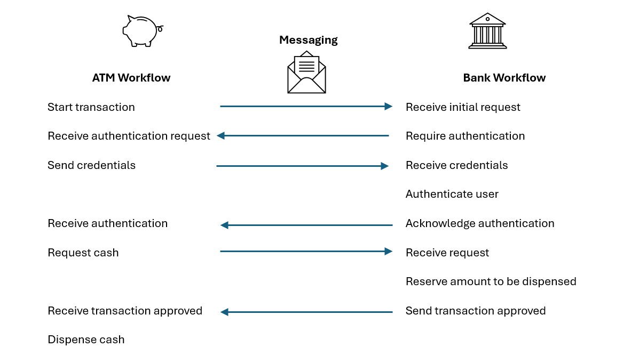
A more complex transaction would be a user booking a trip that involves three entities: The user, a hotel booking system, and an airline booking system:
- The user first queries an airline system to book a flight and gets back a list of potential flights
- The user then queries for a hotel for the same set of days
- After reviewing the two responses, the user requests reservations with the airline and the hotel, providing payment information
- The hotel and airline confirm the bookings
The processing for any of the three participants (user, hotel, airline) may be more complicated than our ATM scenario – in this scenario, for example, the user has to coordinate the reservations available from the other participants. The messages may also, potentially, be more complicated because they contain a list of options (flights, classes of rooms). But the paradigm of multiple workflows between a participant and one or partners, coordinated through messages managed by a messaging resource manager remains the same.

## Noncritical Characteristics
It’s worth recognizing that many aspects of this process are not critical and will vary from one set of participants to another (and even, perhaps, from one transaction to another between any participant and partner).
The message protocol, for example, only needs to be agreed on by any a participant and a single partner. Even in our second, more complicated scenario, for example, the hotel and airline don’t need to share a common protocol because they don’t communicate with each other. While a common protocol for all transactions in all systems would be convenient, it isn’t necessary.
Because each of the participants is a black box to the other participants, how each participant handles its internal state isn’t important to the other participants. In the ATM scenario, for example, the bank will have in place a transaction management system so that any combination of debits and credits required in its part of the distributed transaction are atomic and meet the ACID characteristics. On the other hand, those are not requirements for the user requesting the cash and the user doesn’t need to implement any sort of transaction management.
Even the final state of each participant isn’t known to other participants, except for what is communicated through the messages. In our ATM example, the final step in the user’s workflow might merely dispense the cash the user without reporting the final balance I the user’s account. The user might, then, initiate a second workflow to determine how much money is left in the account.

Timing is also not a constraint. Like any workflow, transactions could stretch over any period of time, if that’s the appropriate “speed of real life” for the transaction. There is always, of course, the possibility that a participant’s workflow may take “too long” for one of its partners and the transaction terminated – but the definition of “too long” will vary from one transaction to another and, possibly, even from one partner to another even in the same transaction.

A message may not even lead to a change of state in one of the participants, as is the case for a participant querying the status of an order placed with another participant, for example.
## Messaging Resource Manager
We can start by defining the characteristics of the resource manager that a participant interacts with to send messages to a partner.
While each participant can keep a record of its state after changes triggered by a message, the history of the transaction is in the conversation between the participant and a partner – the sequence of messages sent and received by the transaction’s participants. That leads to two requirements for the messaging resource manager:
- All the messages in every conversation must be logged for review. To form a legally binding record of the transaction, messages must be logged with block-chain level operational characteristics (i.e. rendered immutable and timestamped)

- Where a participant’s processing is transactional (i.e. subject to commit and rollback), messages must commit and rollback as part of each participant’s transaction: Messages must be enlisted into each participant’s local transaction.

Many current messaging resource managers are not transactional, making processing more complex and imposing unnecessary overhead that prevents transactions that run at “the speed of life.” Typically, local transactions are only scoped to the change of state in the user’s local state and do not include the messages that triggered the change (Oracle’s Transactional Event Queues and Microsoft’s MSMQ are exceptions to this).
Take, for example, the classic transaction scenario of transferring $10 from a user’s saving account to the user’s checking account. In that scenario, if any of the changes to the accounts’ states fail, all changes to all the accounts are rolled back and the account’s state is returned to its condition before any changes are made. Any distributed transaction messages generated by that local transaction must also be committed or rolled back with the rest of the local transaction, otherwise the message log is no longer accurate.
If we extend that scenario to our ATM scenario then, if the transaction succeeds, a message must be sent to the ATM to trigger dispensing the money. If that message isn’t sent then the user doesn’t get the cash and the distributed transaction has failed, even if the user’s account has been successfully debited.
On the other hand, if the change of state at the user’s account fails, a “fail” message notifying the ATM that cash should not be dispensed must be sent. Without that failure message, the ATM will be left in some sort of suspended state, waiting for an acknowledgement that tells it to dispense the cash (or, in this case, to not dispense the case).
Not sending that failure has intensely practical effects because the transaction is not reliable. The transaction also does not happen at “the speed of line”: not only does the user not get their cash, the ATM is rendered unusable for the other customers lined up behind that user. A transactional messaging resource manager ensures that
the legally binding log of the distributed transaction will not have that “unsent” message, reflecting that the transaction was incomplete (as a result, the user will have recourse to recover their money).

The simplest way to enlist messages into the participants’ transaction is write the messages into the transaction journal of each of the participants in the transaction. This avoids the necessity for a local “two phase commit” between the participant’s transactions and the part of the messaging resource manager that the participant is interacting with.
The alternative to enlisting messaging into the local transaction is to wait for the transaction to complete, check whether the local transaction succeeded or failed and then send the “success” or “failure” message. While this is a common practice, it fails to meet the criteria for a distributed transaction.
In addition to adding logical complexity to the participant’s processing, this approach adds additional overhead to a process that needs to operate at “the speed of real life” – instead of streamlining the process, the process is made more cumbersome. More critically, this approach effectively creates a second transaction: preparing the message and queuing it for delivery. If that new transaction fails then either the wrong message or no message is sent, with both outcomes being unacceptable.

## Message Content
We can also define some characteristics for the content of the message protocol. First, of course, each participant and partner combination must jointly agree on the message protocol before the transaction begins.
As part of agreeing on the protocol, participants agree on the structure and type of the content for each message. A completely free message format, for example, will not support the criteria for a distributed transaction: A participant will either, eventually, generate messages that the other participant can not read (not reliable) or incur processing overhead (and will prevent the system from operating at “the speed of real life”). Reviewing the messages in the log between participants becomes more complicated if the format of the messages can not be predicted.
So, like the message content exchanged between participants, the message itself must be typed (which also facilitates enlisting the participants’ local transaction management system in managing the messages).

In a commercial world, messages are hierarchies, not rows: A bill with an order header and order detail is hierarchical; a customer request with its customer information and details of the room/dates required is hierarchical; contracts with information about the parties involved and the subsequent clauses and subclauses are hierarchical.
Currently, messages are structured (almost by default) with JSON. In developing the protocol to be used by two participants, designers often communicate the message formats that will be used by exchanging through examples of the potential JSON documents with sample content (though the JSON Schema supports exchanging information about the message’s type).
While the rows from a relational table can mimic hierarchies, JSON has succeeded as the default messaging protocol because it is inherently hierarchical.
That inherent hierarchical structure is also, of course, a feature of classes in object orient programming languages (and is also a feature of prototypes in, for example, JavaScript). That shared hierarchical nature has made it relatively easy to serialize objects into JSON.
The success of JSON as the default encoding for message content also defines a point of friction with current SQL/relational databases. While hierarchies are natural in both business data and JSON, hierarchies are a side-effect of self-joins in SQL and relational databases (the SQL syntax for retrieving rows in a hierarchy is both unique within the language in using recursion, is relatively opaque, and returns a rowset rather than a hierarchy).
## Participant Workflows
The message protocol must also recognize the nature of workflows: Workflows are state machines and, for each step in a workflow there are a limited number of allowed “next states” and many disallowed “next states.”
In addition, workflows have an event horizon that extends into the future to when the workflow finally reaches its end state. The results of a workflow are not immediate because the future may morph in a way that a participant did not expect. Because of that time-based nature of workflows, states that were allowed at one point may no longer be allowed later: Booking hotel room 3012, for example, may no longer possible because the user has taken too long and the room has been given to someone else; the guarantee of a room may be withdrawn if, in the next step in the workflow, payment is declined.
Which means that, while the messages being sent by a participant need to be transactional, the states in a workflow do not and do not meet the ACID requirements: Rather than being atomic, the states in a workflow form a sequence (“How much cash do you wish to withdraw”) that must be completed by both the participant and the partner before the participant’s workflow finishes; Rather than being isolated, the information used in the workflow must be shared with the partner (“Here is the balance in each of your accounts – which account do you wish to use”?) and changes in the participant and the partner’s states must be synchronized (“The money may be released now”); Rather than being durable, changes in the participant’s state may need to be reversed (“The cash in the account is no longer available”).
As a result, a participant must either defer committing changes until the end of the workflow (typically by reserving some inventory in escrow) or implement compensating transactions that back out changes committed earlier. The more efficient mechanism is to hold information in escrow (“these seats will be held for five minutes”) because the cost of committing changes – and, potentially, backing them out in a compensating transaction – are high.
## Events
Messages can, of course, be explicitly queued, as needed, to the messaging resource manager by a participant.
An alternative is to have the messages that integrate participants generated by events triggered by changes in the participant’s local state. This is especially ture in conversations that involve more than two participants or may grow to have more than two participants because it provides a mechanism that ensures that all the partners involved in the transaction get the messages they are interested in. Because sending the message becomes a side-effect of the participant's local state change this also facilitates enlisting the message into the local transaction. As a result, a participant only has to explicitly send a message to a partner if the current step in their workflow doesn’t involve a change to their internal state (retrieving the balance in a bank account, for example).
In the event scenario, as each participant executes a portion of their workflow, they change their state, potentially adding a message to the conversation between the rest of the participants. Additional participants can join the conversation simply by subscribing to one or more participants’ state changes. Each participant moves through their workflow based on the events they’ve subscribed to in the other participants.
In this model, a partner subscribes to a participant, notifying the participant that the partner is interested in a particular state change made by the participant (for example, any time a user’s account goes into overdraft). By accepting the subscription, the participant accepts a partner and commits to sending the message as part of the state change. As with workflows, this subscription may be long running (e.g. for as long as the partner is active).
This subscribe-to-publish model (exemplified by Oracle’s CQN) reduces the overhead in participants compared to the alternative “publish/subscribe” model where each participant is obliged to raise an event on any state change that might, potentially, be of interest to some potential partner.
In reality, most partners aren’t interested in most of the participant’s state changes or are interested in state changes for only a subset of the participant’s local state (e.g. just for users that have overdraft protection). As a result, in the publish/subscribe model most events raised by a participant have no subscribers. Subscribe-to-publish ensures that events are raised only as long as there’s at least one participant interested in that state change.
Partners may also need to request events to be raised when states in the participant have not changed after an event. A participant may, for example, be interested when a user’s account goes into overdraft but, also, be interested if the account is still in overdraft an hour later. Without that event, a partner who is interested in that state is obliged to poll the participant.
In addition, simply because an event was raised and a message was sent, it does not mean that the message was received by the partner. There may be transient transmission problems or the partner who was to receive the message may be offline. In either scenario, the participant is obliged to resend the message tied to the event until an acknowledgement that the message was successfully delivered is received (which is the responsibility of the messaging resource manager). To support resending, messages must also be immutable.
And every message doesn’t have to be sent immediately – some latency may be acceptable to the partner and, when that’s available, it reduces the processing demands on the participant.
To support the subscribe-to-publish model, participants must expose an interface that describes what a partner may request when subscribing. Optionally, as part of subscribing, the partner can specify what latency is acceptable, and what subsequent notifications are required. The participant defines what part of its local store is relevant to the state change and is returned in the message (though, again optionally, the participant can expose an interface and allow the partner to request some subset of that interface to be returned – OData provides a model here).
## Requirements for Participant’s Local Store
Because the messaging resource manager holds all of the messages and messages are immutable, it is possible to replay any conversation provided the data held by the participants is temporal: After each state change, each participant must keep an immutable copy of the changed data from before the state change.

